**ASSIGNMENT 4**

|  |  |
| --- | --- |
| **Date** | **25 October 2022** |
| **Team ID** | **PNT2022TMID06145** |
| **Project Name** | Real Time River water quality monitoring and Control system |
| **Maximum Marks** | **4 Mark** |

Project Title**:** Real Time River water quality monitoring and Control system

**Team Members:**

1. **Hari Raama Krishnan S- Team Leader**
2. **Saran R-Team Member**
3. **Parthasarathi S- Team Member**
4. **Sasikumar M– Team Member**
5. **Mohamed Alla Pitchai M- Team Member**

**QUESTION:**

**Write code and connections in wokwi for ultrasonic sensor. Whenever distance is less than 100 cms send "alert" to ibm cloud and display in device recent events.**

# CODE:

#include <WiFi.h> #include

<PubSubClient.h>

void callback(char* subscribetopic, byte* payload, unsigned int payloadLength);

//-------credentials of IBM Accounts------

#define ORG "Ashfaq1824"//IBM ORGANITION ID

#define DEVICE_TYPE "ESP32"//Device type mentioned in ibm watson IOT Platform #define DEVICE_ID "12345"//Device ID mentioned in ibm watson IOT Platform #define TOKEN "12345678" //Token

String data3;

char server[] = ORG

".messaging.internetofthings.ibmcloud.com"; char publishTopic[] = "iot-2/evt/Data/fmt/json"; char subscribetopic[] = "iot-2/cmd/test/fmt/String"; char authMethod[] = "use-token-auth";

char token[] = TOKEN;

char clientId[] = "d:" ORG ":" DEVICE_TYPE ":" DEVICE_ID;

WiFiClient wifiClient;

PubSubClient client(server, 1883, callback ,wifiClient); const int trigPin = 5;const int echoPin = 18

#define SOUND_SPEED

0.034 long duration; float distance; void setup() { **Serial**.begin(115200); pinMode(trigPin, OUTPUT); pinMode(echoPin, INPUT); wificonnect(); mqttconnect();

} void loop() { digitalWrite(trigPin, LOW); delayMicroseconds(2); digitalWrite(trigPin, HIGH); delayMicroseconds(10); digitalWrite(trigPin, LOW); duration = pulseIn(echoPin, HIGH); distance = duration * SOUND_SPEED/2;

**Serial**.print("Distance (cm): "); **Serial**.println(distance); if(distance<100)

{

**Serial**.println("ALERT!!"

); delay(1000); PublishData(distance); delay(1000); if (!client.loop()) { mqttconnect();

} }

delay(1000

); }

void PublishData(float dist) { mqttconnect();

String payload = "{\"Distance\":"; payload += dist;

payload += ",\"ALERT!!\":""\"Distance less than 100cms\""; payload += "}";

**Serial**.print("Sending payload: ");

**Serial**.println(payload);

if (client.publish(publishTopic, (char*) payload.c_str())) {

**Serial**.println("Publish ok");

} else {

**Serial**.println("Publish failed");

} } void mqttconnect() { if (!client.connected()) { **Serial**.print("Reconnecting client to ");

**Serial**.println(server);

while (!!!client.connect(clientId, authMethod, token)) {

**Serial**.print("."); delay(500);

}

initManagedDevice();

**Serial**.println();

} }

void wificonnect()

{

**Serial**.println(); **Serial**.print("Connecting to "); WiFi.begin("Wokwi-GUEST", "", 6);

while (WiFi.status() != WL_CONNECTED) { delay(500);

**Serial**.print(".");

}

**Serial**.println(""); **Serial**.println("WiFi connected"); **Serial**.println("IP address: "); **Serial**.println(WiFi.localIP());

}

void initManagedDevice() { if (client.subscribe(subscribetopic)) { **Serial**.println((subscribetopic)); **Serial**.println("subscribe to cmd OK");

} else {

**Serial**.println("subscribe to cmd FAILED");

} }

void callback(char* subscribetopic, byte* payload, unsigned int payloadLength) {

**Serial**.print("callback invoked for topic: "); **Serial**.println(subscribetopic); for (int i = 0; i < payloadLength; i++) {

//Serial.print((char)payload[i]); data3 += (char)payload[i];

}

**Serial**.println("data: "+ data3); data3="";

}

# SCHEMATIC/CIRCUIT DIAGRAM:

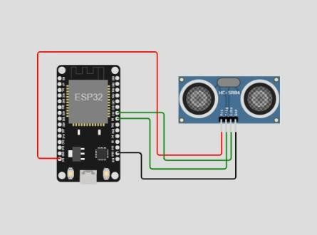

IBM CLOUD OUTPUT:

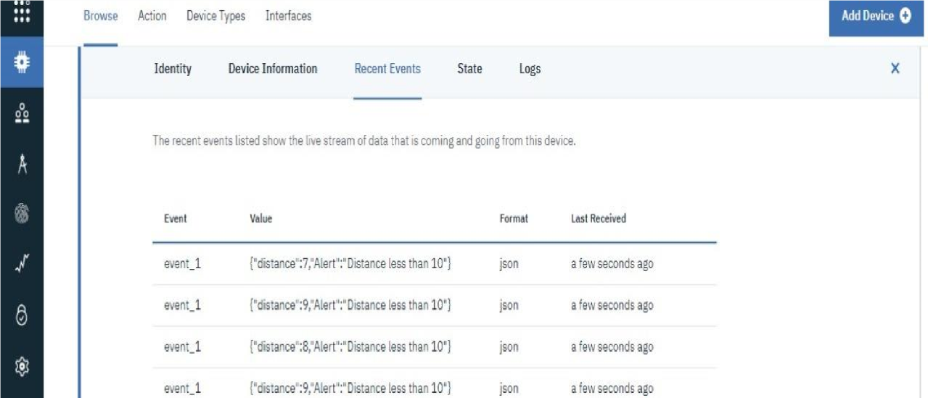

# WOKWI LINK:

https://wokwi.com/projects/322410731508073042